Dear Jessica and Brennan,

Missing Drip Cap Over Window

We have an important issue that needs to be addressed ASAP. The Drip Cap was never installed over the window where we’ve had leakage. We need to have the window covered in plastic or some other protection right away to prevent further damage.

We have duct tape currently covering the area, but this is hardly a solution.

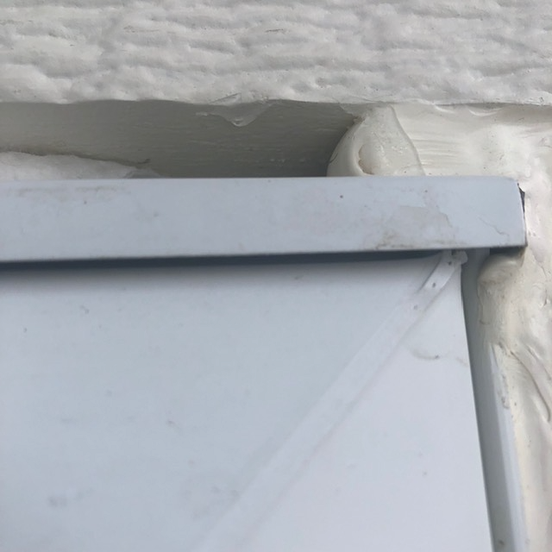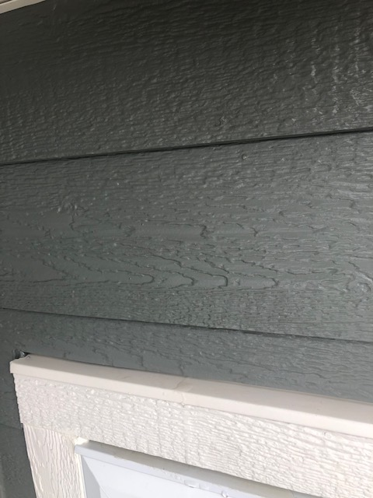

Missing Drip Cap

Due to the missing drip cap, the water is pooling on the top exterior ledge of the window, leaking in and causing interior damage. We have videos that show the pooling.

Interior Water Damage

There has been leakage from the window head dripping on the sill, running down the jamb staining the wall and damaging trim and framing. We are concerned that water dripped down the jamb into the wall and worry about possible mold. (See pictures below on several pages)

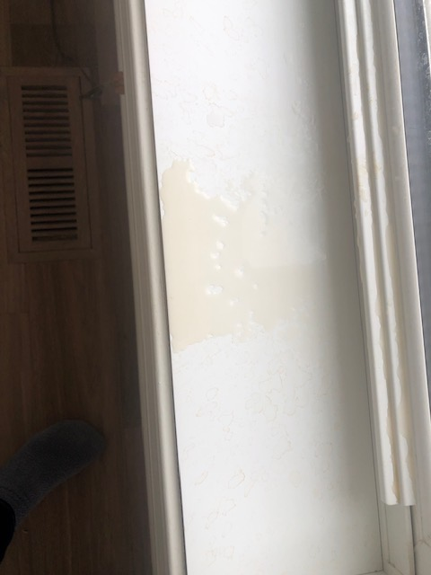

Pooling on window sill

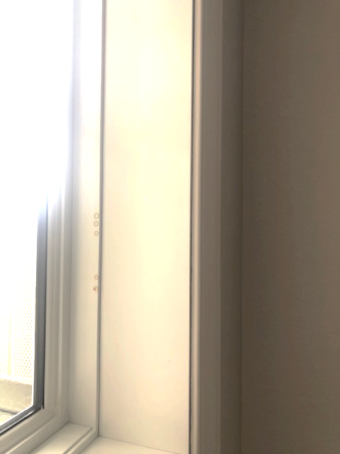

Interior view of water dripping in from window head

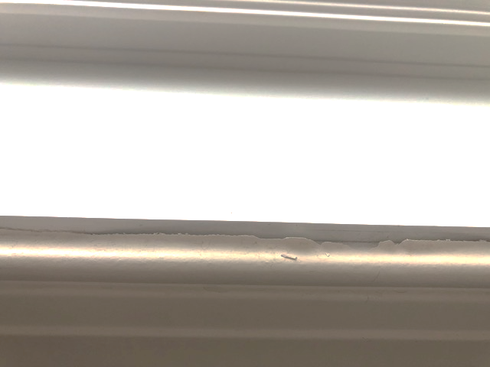

Damage to trim below window sill

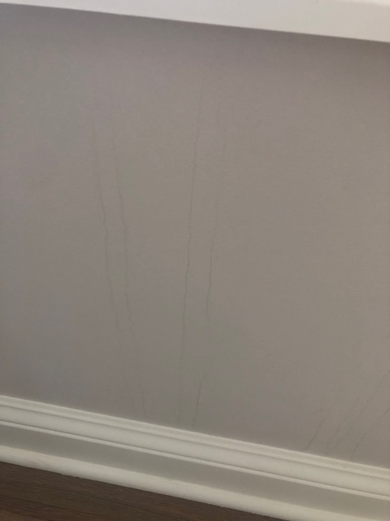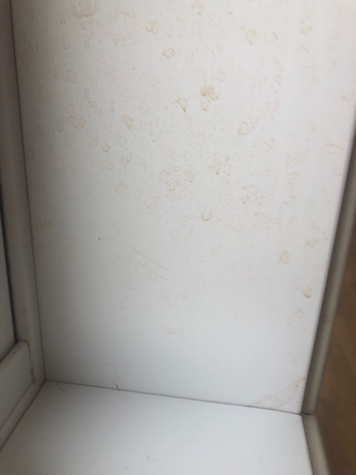

Wall damage Drainage down window jamb

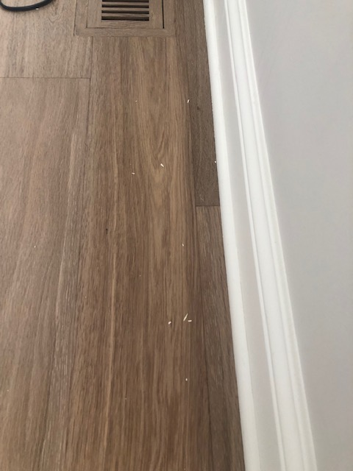

Trim Peeling on floor

